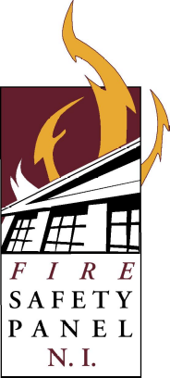
FIRE SAFETY PANEL CONFERENCE

7TH & 8TH FEBRUARY 2019

ARMAGH CITY HOTEL
F I R E
S A F E T Y
P A N E L
B C N I

BOOKING FORM

I wish to attend the 2019 Fire Safety Conference:

Name:
Email Address:
(For Booking Confirmation)
Contact Number:
Authority/Company:
Invoice Address:
Invoice Email Address:
Purchase Order No:
(MANDATORY)

Conference Fees
 | Full Delegate:  £250 plus VAT = £300  Inc. Conference dinner, overnight stay and use of Hotel Health & Fitness Club |  |  |  | Student* 2 Day Residential Delegate:  £100 incl. VAT  Inc. Conference dinner, overnight stay and use of Hotel Health & Fitness Club
 | 2 Day Non Residential Delegate:  £175 plus VAT = £210 |  |  | *Student must be in full-time education | Student* Rate per Day:  £30 plus VAT = £36 | 7th | 8th
 | Day Delegate:  £125 plus VAT = £150  Inc. lunch | 7th | 8th | Please note any Dietary Requirements or Accessibility Requests here:
Conference Dinner:
£30 plus VAT = £36

How to Register

All bookings to be received by Friday 18th January 2019 – Early Booking is essential.

 | By email: | firesafetypanel@gmail.com
 | By telephone: | Joanne Virtue Tel: 028 6632 1807

ALL BOOKINGS WILL BE INVOICED BY FERMANAGH AND OMAGH DISTRICT COUNCIL
In accordance with Data Protection legislation, Building Control Northern Ireland Fire Safety Panel has a duty to protect any data we hold on you. The information you provide on this Booking form will be used for the purposes of administration of the Fire Safety Conference and will be shared with other Councils.
If you do not wish us to hold your information for future Conferences, please tick the box:

